**Coding Assessment – Data Cleaning and Pandas**

1. **Loading Data in Pandas DataFrame**

import pandas as pd

# Load the dataset

df = pd.read_csv('loan_data.csv')

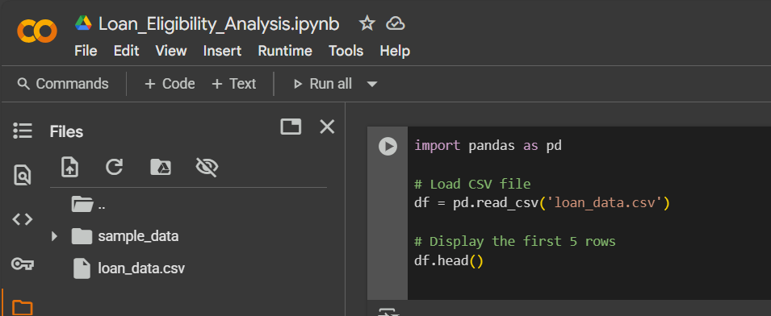

1. **Printing rows of the Data**

# Show first 5 rows

df.head()

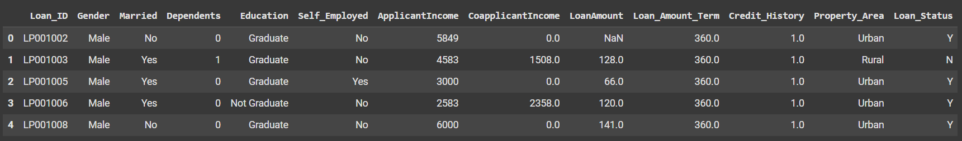

1. **Printing the column names of the DataFrame**

* print(df.columns)

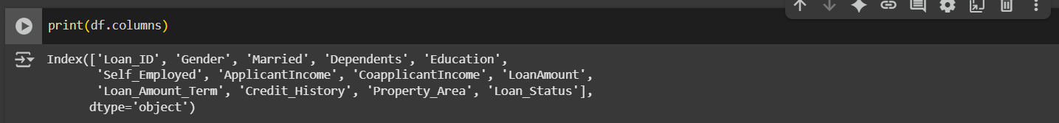

1. **Summary of Data Frame**

* df.info()

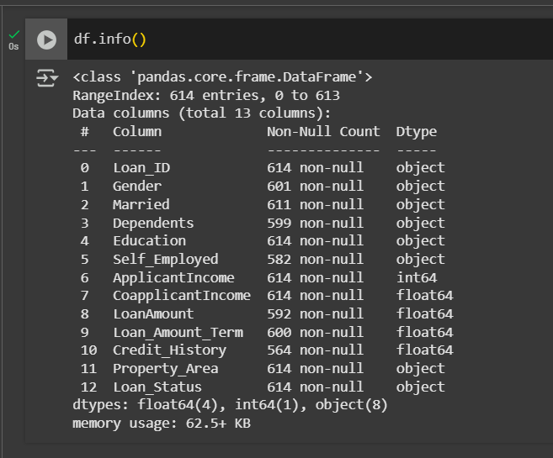

1. **Descriptive Statistical Measures of a DataFrame**

* df.describe()

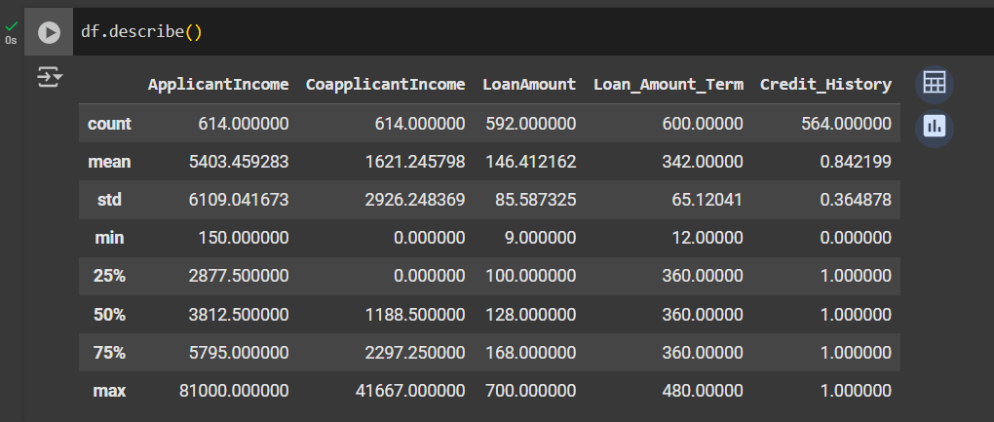

1. **Missing Data Handing**

* df.isnull( ).sum( )

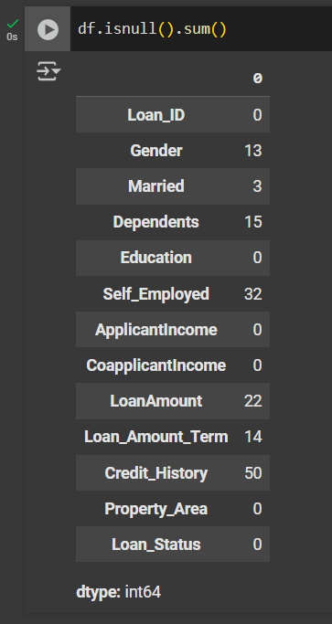

1. **Sorting DataFrame values**

# Sort by LoanAmount (descending)

df.sort_values(by='LoanAmount', ascending=False).head()



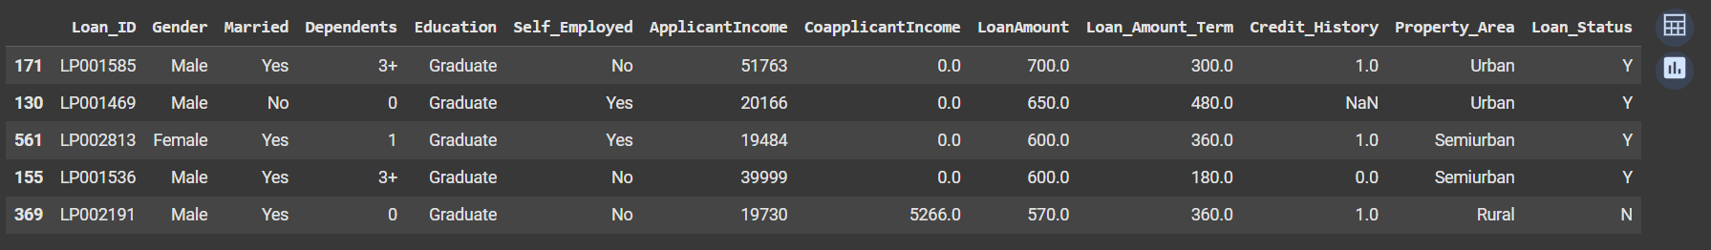

1. **Merge Data Frames**

df1 = pd.DataFrame({

'Loan_ID': ['LP001002', 'LP001003'],

'Loan_Status': ['Y', 'N']})

df2 = pd.DataFrame({

'Loan_ID': ['LP001002', 'LP001003'],

'Property_Area': ['Urban', 'Rural']})

merged = pd.merge(df1, df2, on='Loan_ID')

merged

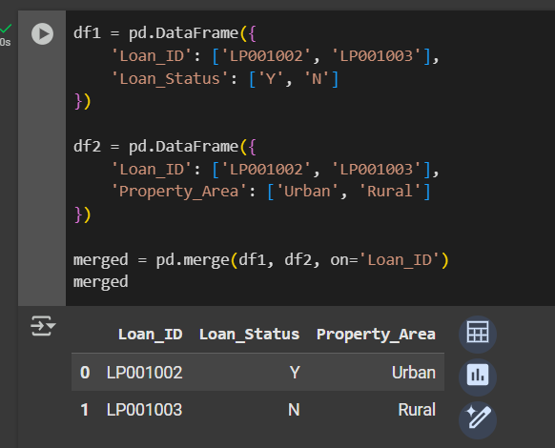

1. **Apply Function**

# Create a new column 'TotalIncome'

df['TotalIncome']=df['ApplicantIncome']+ df['CoapplicantIncome']

def income_category(income):

if income < 2500:

return 'Low'

elif income < 6000:

return 'Medium'

else:

return 'High'

df['Income_Category'] = df['TotalIncome'].apply(income_category)

df[['TotalIncome', 'Income_Category']].head()

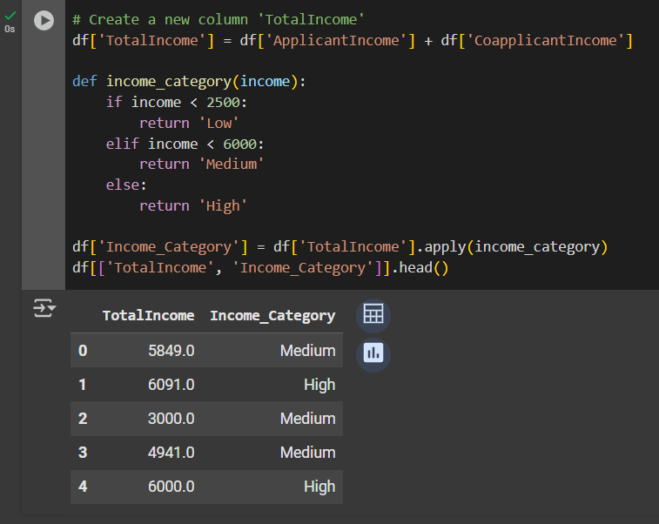

1. **By using the lambda operator**

# Add 10% tax to LoanAmount (demo)

df['LoanAmount_Tax'] = df['LoanAmount'].apply(lambda x: x * 1.1)

df[['LoanAmount', 'LoanAmount_Tax']].head()

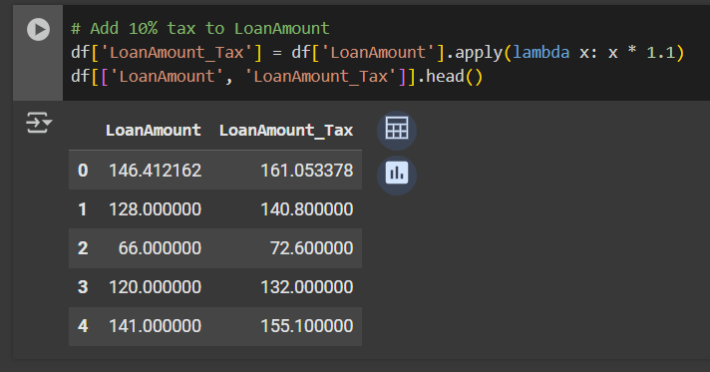

1. **Visualizing DataFrame**

import matplotlib.pyplot as plt

import seaborn as sns

# Plot gender count

sns.countplot(x='Gender', data=df)

plt.title('Gender Distribution')

plt.show()

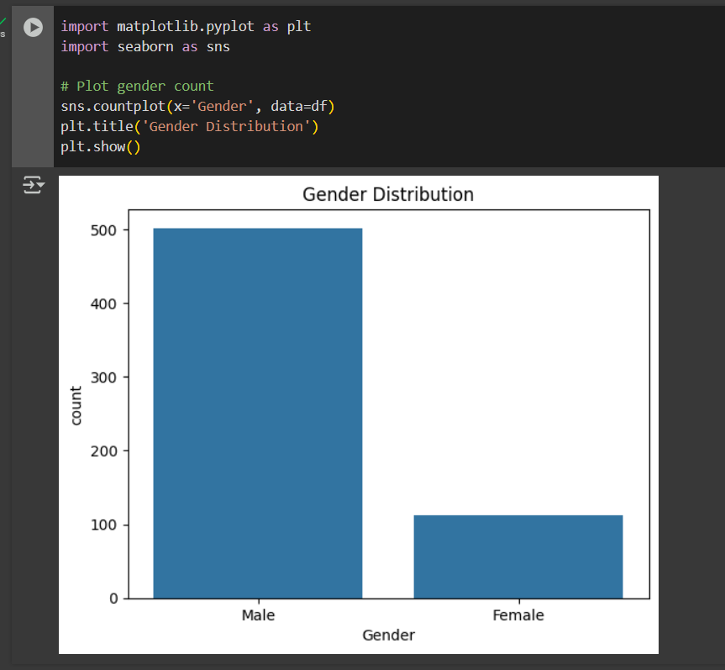

**Loan status by education**

sns.countplot(x='Education', hue='Loan_Status', data=df)

plt.title('Loan Status by Education')

plt.show()

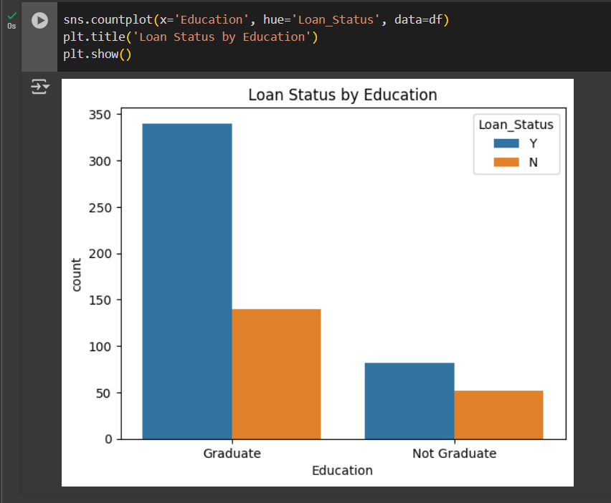

**Pandas Joins**

import pandas as pd

# Loan application data

loan_df = pd.DataFrame({

'Loan_ID': ['LP001002', 'LP001003', 'LP001004', 'LP001005'],

'Gender': ['Male', 'Male', 'Male', 'Male'],

'Married': ['No', 'Yes', 'Yes', 'Yes'],

'ApplicantIncome': [5849, 4583, 3000, 2583]})

# Income data from another source

income_df = pd.DataFrame({

'Loan_ID': ['LP001002', 'LP001003', 'LP001006'],

'AdditionalIncome': [0, 1500, 2400]})

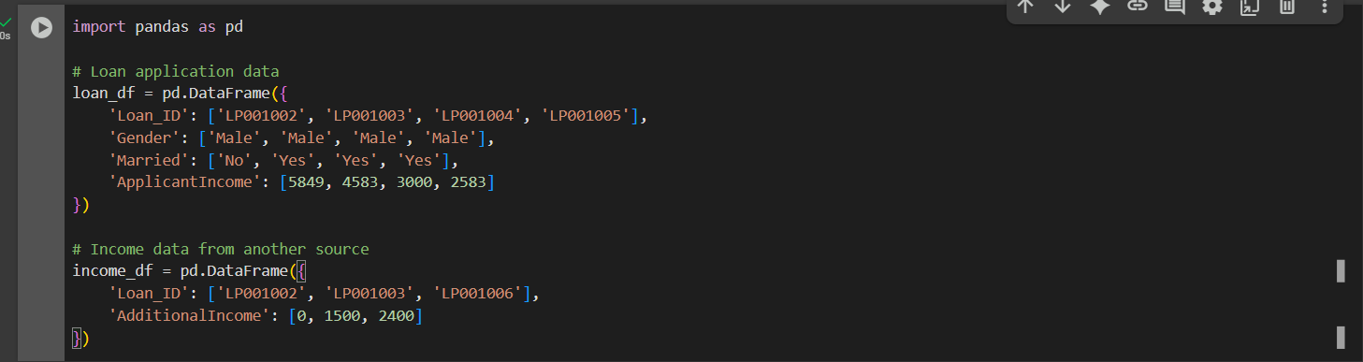

1. **Inner Join**

Returns only rows with matching Loan_ID in both DataFrames.

inner_join = pd.merge(loan_df, income_df, on='Loan_ID', how='inner')

print(" INNER JOIN:")

print(inner_join)

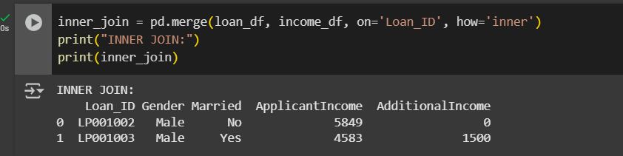

1. **Left Join**

Returns all records from loan_df and matching rows from income_df.

left_join = pd.merge(loan_df, income_df, on='Loan_ID', how='left')

print(" LEFT JOIN:")

print(left_join)

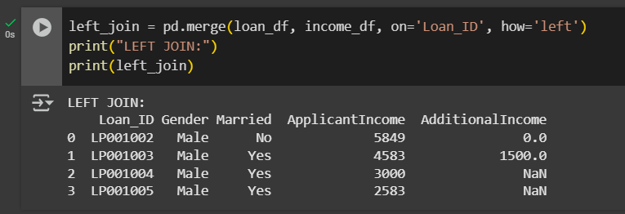

1. **Right Join**

Returns all records from income_df and matching ones from loan_df.

right_join = pd.merge(loan_df, income_df, on='Loan_ID', how='right')

print(" RIGHT JOIN:")

print(right_join)

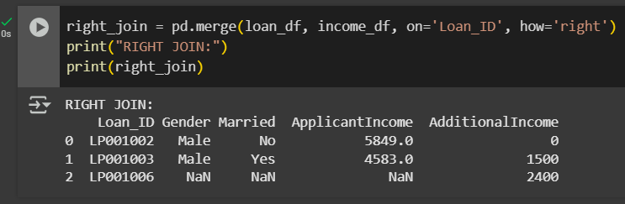

1. **Outer Join**

Returns all rows from both DataFrames. Non-matching fields are filled with NaN.

outer_join = pd.merge(loan_df, income_df, on='Loan_ID', how='outer')

print(" OUTER JOIN:")

print(outer_join)

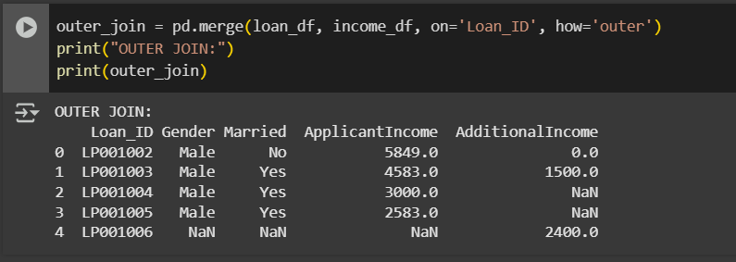

**Submitted by**

Siva Balan T